Manila Water Company

FUNCTIONAL SPECIFICATION – REPORT

<DID_S2P_354>

Work Accomplishment Report

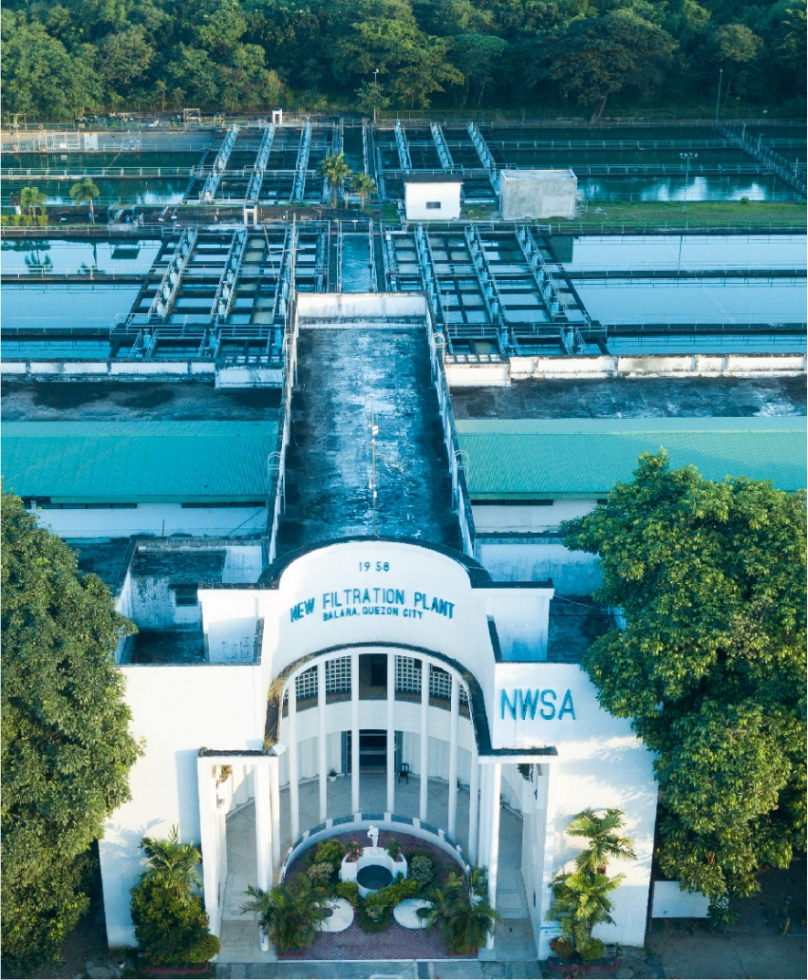

Customer NameDocument Title





[How to use the Template: This chapter gives only explanations on the template. Remove it before completing the template.
Blue text is always intended as instructions, guidelines, explanations, hints, and tips. It should always be removed from the template for the project.
Update Fields in Document: If you want to update all fields, press "CTRL+A," then "F9". You will get pop-ups sequentially, which ask you for the new values. Afterwards go to the footer area, then press "CTRL+A" and "F9" again.
Top-level chapters may not be deleted or inserted; required additions should be made as sub-chapters to existing chapters to provide a consistent representation of this document to the customer. To keep the numbering of the chapters consistent over all specifications (of the project), do NOT delete top-level chapters that are not relevant in a concrete document; only mark them as not relevant (that is, add “not relevant” or “not applicable”).]
[Document Version Status has four values: Draft, Ready for Review, Reviewed with Comments and Final. If the document send by an Author(s) without an intention of a Review should have a status as Draft. A Draft document may have some incomplete sections.
If the document send by an Author(s) with an intention of a Review should have a status as Ready for Review. All the sections in the document are expected to be completed in this case.
Reviewer(s) should set only two statuses:
- Reviewed with Comments – if documents needs to send the document to Author(s).
- Final – marks the acceptance of reviewer for the document.]
You can for example number the appropriate versions as follows:
0.1 Draft
0.2 Ready for Review
0.3 Reviewed with Comments (in case document is send back to author(s)
0.3 Ready for Review (in case of major changes)
1.0 Final

In case of fundamental changes:
1.1 Draft (new draft version that has to pass a review again)
1.2 Ready for internal review
1.3 Ready for Review
2.0 Final

Contents
1 Document Organization 5
1.1 Document Log 5
1.2 Integration, Document Reference 5
2 Justification 6
3 Functional Description 6
4 Transaction Volume 6
5 Frequency & Timing 6
6 Dependencies 6
7 Selection Criteria 6
8 Validation of Selection Criteria 7
9 Authorization Requirements 7
9.1 Definition 7
9.2 Defined Fields 7
9.3 Procedure 7
10 Variants 7
11 Functional Design 7
12 Report Output 7
12.1 Output Method 7
12.2 Main Heading 7
12.3 Sub Heading 7
12.4 Layout 8
12.5 Report Header & Footer 8
13 Assumptions in Functional Design 8
14 Open Issues in Functional Design 8
15 Business Test Conditions 8
16 Related Documentation 9

Document Organization
This section provides details about this document, previous version(s) of this document and the document(s) referred.

Document Log
[Please specify information about Version changes in the following table. The first version should be specified in the first row and the current (latest) version should be specified in the last row]
[The Version Created by details should be specified as:
First Name followed by Last Name
Email
Company]
Following table mentions the version changes and the processer(s):
Version | Status | Date | Version Created by (Name/E-Mail/Company) | Role | Comments
0.1 | Ready for Review | July 5, 2025 | Alok Dubey | Author
 | Choose an item. | Click here to enter a date. |  | Choose an item.

Integration, Document Reference
N/A

Justification
There is no standard report available in SAP to fetch the data required in this report.

Functional Description
This document provides detailed functional requirements for developing a customized Work Accomplishment Report in SAP. The purpose of this report is to meet specific business requirements that are not fulfilled in the standard SAP. It provides information on the status Service Entry Sheet created for a PO along with corresponding Invoice details and other related information.
- Header Information: The header of report will have the below information: -
- Job Order no
- Description
- Contractor
- Purpose
- WAR No
- Project code
- No of Entries
- Contract duration
- Contract NTP/Start date
- Contract expiry date
- Approved time extension
- Finish Date

- Item details: The item details in table will have below information: -
- Item code
- Description
- Unit
- Unit bid price
- Contract Qty
- Contract Cost
- Accomp.Prev Qty
- Accomp.Prev Cost
- Accomp.Curr Qty
- Accomp.Curr Cost
- Accomp.TD Qty
- Accomplished TR Cost
- Parked + Posted Cost
- Payment Billable Cost
- Payment TD Cost

Transaction Volume
N/A

Frequency & Timing
N/A

Dependencies
N/A

Selection Criteria

Table/  Structure Name | Field Name | Format | Default Value | Table Value/  Checkbox/  Radio Button/  Radio Button Group | Select Option or Parameter | Mandatory or Optional | Field Labels
EKKO | EBELN | NUMC | NA | Table Value | Parameter | Mandatory | Purchase Order
MMPUR_SES_header | SERVICEENTRYSHEET | NUMC | NA | Table Value | Parameter | Mandatory | SES Number
 |  | CHAR | NA | Table Value | Parameter | Mandatory | Purpose
 |  | NUMC | NA | Table Value | Parameter | Mandatory | Approved time extension

*In the Purpose field there will be drop down with options- Progress Billing / First billing /Final Billing / One time Billing
*Approved time extension – Numeric field for manual entry

Purchase Order | 4500000001
SES Number | 100000051
Purpose | Drop down
Approved time extension (Days) | Manual entry numeric

Validation of Selection Criteria
N/A

Authorization Requirements
N/A

Definition
N/A

Defined Fields
N/A

Procedure
N/A

Variants
N/A

Functional Design
Header Fields | Logic to fetch data
FROM | Pass SES number into MMPUR_SES_ITEM- SERVICEENTRYSHEET and fetch from date PERFORMANCEDATE
TO | Pass SES number into MMPUR_SES_ITEM- SERVICEENTRYSHEET and fetch to date PERFORMANCEENDDATE
Job Order No | This is the PO number entered in selection screen (EKKO-EBELN)
Project code | This is the Project code of the WBS or Network used in the PO.  Pass PO number from selection screen EBELN into EKKN- EBELN to fetch WBS element from PS_PSP_PNR. Pass WBS element into PRPS- PSPNR and fetch project code from PSPHI.  If PS_PSP_PNR is not having values then,  Pass PO number into EKKN-EBELN to fetch Network order from NPLNR. Pass Network order NPLNR into AFKO-AUFNR and fetch project code from PRONR.
Description | Pass project code PSPNR into PROJ table and fetch POST1
Contractor | This the supplier/vendor in the Purchase Order  Pass PO number from selection screen into EKKO-EBELN and fetch vendor number LIFNR. Pass vendor number into table LFA1-LIFNR and fetch vendor name NAME1.
Purpose | This is fetched from the selection screen
WAR No. | This is the SES number entered in the selection screen (MMPUR_SES_HEADER- SERVICEENTRYSHEET)
No. of Entries
Contract Duration | This is total number of data lines in the report (Item details)
Contract NTP/ Start date | This the start date maintained in the Project definition.  Pass Project code into PROJ -PSPNR and fetch PROJ-PLFAZ
Contract expiry date | This the End date maintained in the Project definition.  Pass Project code into PROJ -PSPNR and fetch PROJ-PLSEZ
Approved time extension | This is fetched from the selection screen
Finish date | Add Approved time extension days to Contract expiry date to get Finish date.

Items Fields | Logic to fetch data
Item code | This is the product in SES maintained the selection screen.  Pass SES number in MMPUR_SES_ITEM – SERVICEENTRYSHEET and fetch the product MMPUR_SES_ITEM -SERVICE
Description | Pass SES number in MMPUR_SES_ITEM – SERVICEENTRYSHEET and fetch DESCRIPTION
Unit | Pass SES number into MMPUR_SES_ITEM -SERVICEENTRYSHEET and item number in MMPUR_SES_ITEM -SERVICEENTRYSHEETITEM and fetch unit MMPUR_SES_ITEM -UNIT
Unit Bid Price | Pass SES number into MMPUR_SES_ITEM -SERVICEENTRYSHEET and item number in MMPUR_SES_ITEM -SERVICEENTRYSHEETITEM and fetch PO number REFERENCEPURCHASEORDER and PO item REFERENCEPURCHASEORDERITEM. Pass PO number into EKPO-EBELN and PO item into EKPO-EBELP and fetch unit price NETPR.
Contract Qty | Pass SES number into MMPUR_SES_ITEM -SERVICEENTRYSHEET and item number in MMPUR_SES_ITEM -SERVICEENTRYSHEETITEM and PO number REFERENCEPURCHASEORDER and PO item REFERENCEPURCHASEORDERITEM. Pass PO number into EKPO-EBELN and PO item into EKPO-EBELP and fetch order quantity MENGE.
Contract Cost | Pass SES number into MMPUR_SES_ITEM -SERVICEENTRYSHEET and item number in MMPUR_SES_ITEM -SERVICEENTRYSHEETITEM and PO number REFERENCEPURCHASEORDER and PO item REFERENCEPURCHASEORDERITEM. Pass PO number into EKPO-EBELN and PO item into EKPO-EBELP and fetch order value NETWR.
Accomplished Previous Qty | This is sum of the quantities from all the SES created for the PO line item before the current SES.  Pass SES number into MMPUR_SES_ITEM -SERVICEENTRYSHEET and item number in MMPUR_SES_ITEM -SERVICEENTRYSHEETITEM and fetch PO number REFERENCEPURCHASEORDER and PO item REFERENCEPURCHASEORDERITEM.  Pass PO number into MMPUR_SES_ITEM- REFERENCEPURCHASEORDER and PO line MMPUR_SES_ITEM- REFERENCEPURCHASEORDERITEM and fetch QUANTITY of all SES where SES number SERVICEENTRYSHEET is less than SES number in selection screen. Sum of all the quantities is Accomplished Previous Qty
Accomplished Previous Cost | This is sum of the amounts from all the SES created for the PO line item before the current SES.  Pass SES number into MMPUR_SES_ITEM -SERVICEENTRYSHEET and item number in MMPUR_SES_ITEM -SERVICEENTRYSHEETITEM and fetch PO number REFERENCEPURCHASEORDER and PO item REFERENCEPURCHASEORDERITEM.  Pass PO number into MMPUR_SES_ITEM- REFERENCEPURCHASEORDER and PO line MMPUR_SES_ITEM- REFERENCEPURCHASEORDERITEM and fetch NETAMOUNT for all SES where SES number SERVICEENTRYSHEET is less than SES number in selection screen. Sum of all the amounts is Accomplished Previous Cost
Accomplished Current Qty | This is the quantity in the SES entered in selection screen  Pass SES number into MMPUR_SES_ITEM -SERVICEENTRYSHEET and item number in MMPUR_SES_ITEM -SERVICEENTRYSHEETITEM and fetch QUANTITY.
Accomplished Current cost | This is the amount in the SES entered in selection screen  Pass SES number into MMPUR_SES_ITEM -SERVICEENTRYSHEET and item number in MMPUR_SES_ITEM -SERVICEENTRYSHEETITEM and fetch NETAMOUNT
Accomplished TD Qty | This is the sum of Accomplished Previous Qty + Accomplished Current Qty
Accomplished TD cost | This is the sum of Accomplished Previous Cost + Accomplished Current cost
Parked + Posted cost | Pass SERVICEENTRYSHEET into EKBE- LFBNR and SERVICEENTRYSHEETITEM into EKBE-LFPOS and fetch invoice number BELNR and item BUZEI and year GJAHR where BEWTP = Q  Pass invoice number into RSEG- BELNR, line item into RSEG- BUZEI and year into RSEG-GJAHR and fetch WRBTR where RBKP- STBLG EQ Blank
Payment Billable Cost | Pass invoice number into RBKP-BELNR and year into RBKP-GJAHR and fetch status RBKP- RBSTAT. If RBKP-RBSTAT NE 4 or 5 and RBKP- STBLG EQ Blank then Pass invoice number into RSEG- BELNR, line item into RSEG- BUZEI and year into RSEG-GJAHR and fetch WRBTR.
Payment TD cost | Pass invoice number into RBKP-BELNR and year into RBKP-GJAHR and fetch status RBKP- RBSTAT. If RBKP-RBSTAT EQ 4 or 5 and RBKP- STBLG EQ Blank then Pass invoice number into RSEG- BELNR, line item into RSEG- BUZEI and year into RSEG-GJAHR and fetch WRBTR.

Sample Report

Report Output

Output Method
N/A

Main Heading

MANILA WATER COMPANY, INC.
WORK ACCOMPLISHMENT REPORT – Civil Works

Sub Heading
N/A

Layout

Report Header & Footer
N/A

Assumptions in Functional Design
N/A

Open Issues in Functional Design
N/A

Business Test Conditions

Scenario # | Input Selection Criteria | Expected Result
1 | Extract the WAR report by entering the PO number and SES number | The system displays the WAR report for all service line items in the SES.

Related Documentation
N/A

